On Becoming a People’s College: An Appreciative Inquiry is a dissertation research project for Sean Crossland's Ph.D. in Educational Leadership & Policy from the University of Utah (https://elp.utah.edu/). Sean is also the director of the Thayne Center for Service & Learning at Salt Lake Community College (https://www.slcc.edu/thaynecenter/).
“At its heart, [Appreciative Inquiry] AI is about the search for the best in people, their organizations, and the strengths-filled, opportunity-rich world around them. AI is not so much a shift in the methods and models of organizational change, but AI is a fundamental shift in the overall perspective taken throughout the entire change process to ‘see’ the wholeness of the human system and to “inquire” into that system’s strengths, possibilities, and successes. ”
The framework for this inquiry operates at the convergence of democratic engagement and equity. “The conversation about diversity and inclusion has profound implications for the legitimacy and efficacy of community engagement work”. Authentic efforts to enhance democratic engagement require us to recognize historically underrepresented voices in decision-making processes, constantly interrogate power dynamics, and critically examine the impacts and implications of collective and individual efforts.
The intended outcomes for this project are threefold:
- A series of recommendations and commendations for De Anza. The recommendations intend to nourish your collective work. The commendations will be shared broadly with the intent of benefiting the field, including with the Community Learning Partnership (http://communitylearningpartnership.org/).
- A co-authored paper with Angelica Esquivel Moreno and self-selecting VIDA interns. This paper seeks to offer a rich qualitative perspective of how students' identity interacts with their experiences at De Anza College, and how the institution can be more accountable to students’ future directions. Students will engage with Stanford’s Pathways to Public Service and Civic Engagement (https://haas.stanford.edu/about/about-our-work/pathways-public-service).
- An auto-ethnography of my experience using the Appreciative Inquiry method as a publicly engaged scholar. This will include engaging with my own social status, experiences from my graduate studies, and reflections on my time at De Anza.
On the reverse side, you will find a mind-map of my approach to this project. This is not necessarily a linear process, so I welcome contributions to any stage at any time. I am happy to share anything useful from my doctoral studies or experience at SLCC. This project strives for reciprocity.
I welcome your perspective however is most convenient:
Email: sean@thecrosslands.net | Cell: 801-867-2212 | Meeting: https://calendly.com/spc | other

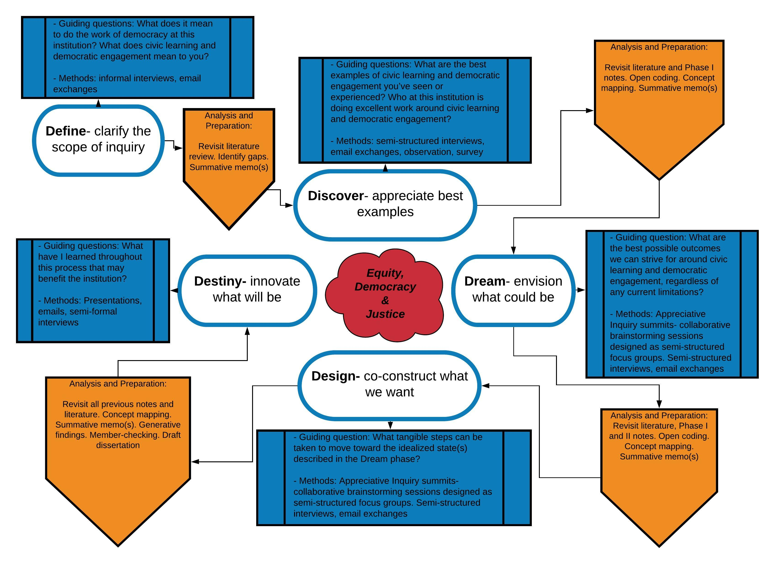

Stavros, Jacqueline, Godwin, Lindsey, & Cooperrider, David. (2015). Appreciative Inquiry: Organization Development and the Strengths Revolution. In Practicing Organization Development: A guide to leading change and transformation (4th Edition), William Rothwell, Roland Sullivan, and Jacqueline Stavros (Eds). Wiley https://appreciativeinquiry.champlain.edu
Sturm, Susan, Eatman, Tim, Saltmarsh, John & Bush, Adam. (2011). “Full Participation: Building the Architecture for Diversity and Public Engagement in Higher Education.” White Paper, Columbia University Law School, Center for Institutional and Social Change, Available Online at https://imaginingamerica.org/wp-content/uploads/2015/07/fullparticipation.pdf

